Civil war in Somalia
UNSC Resolution: | 814
Date of adoption: | 26-Mar-1993
Operative paragraph: | 9
Demand number: | 814,0911

Sarah-Myriam Martin-Brûlé

Wording of demand
- take all measures to ensure the safety of the personnel of the United Nations and its agencies as well as the staff of the International Committee of the Red Cross (ICRC), intergovernmental organizations and non-governmental organizations engaged in providing humanitarian and other assistance to the people of Somalia in rehabilitating their political institutions and a and promoting political settlement and national reconciliation

List of addressees of the demand
- Government of Somalia, United Somali Congress Faction

Short-term compliance

Description of the addressee(s)’ conduct

“The representative of the United States contended that the actions against UNOSOM II
threatened international peace and security and had to be dealt with accordingly . She further stated that factional violence was impermissible under the terms of resolution 814 (1993) and that hostilities aimed at United Nations forces were a gross violation of paragraph 9 of that resolution.”

Repertoire of the Practice of hte Security Council, 1993-1995, The Situation in Somalia,
http://www.un.org/Depts/dpa/repertoire/index.html

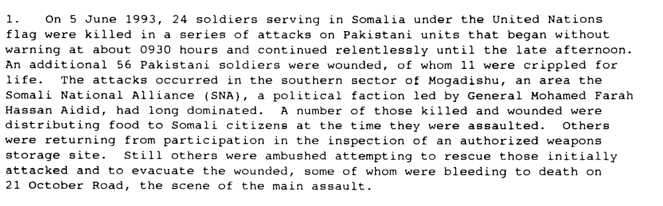

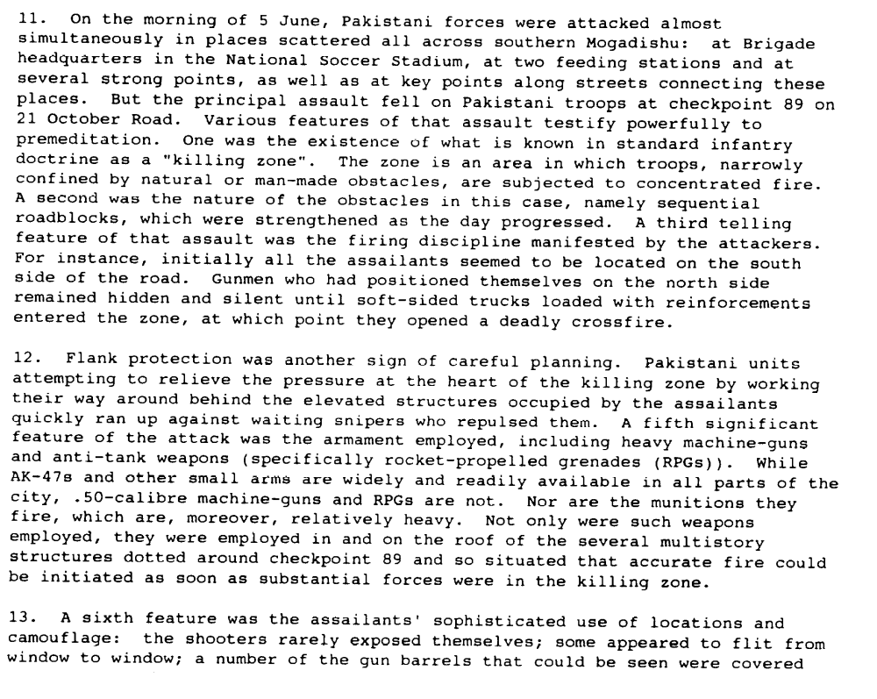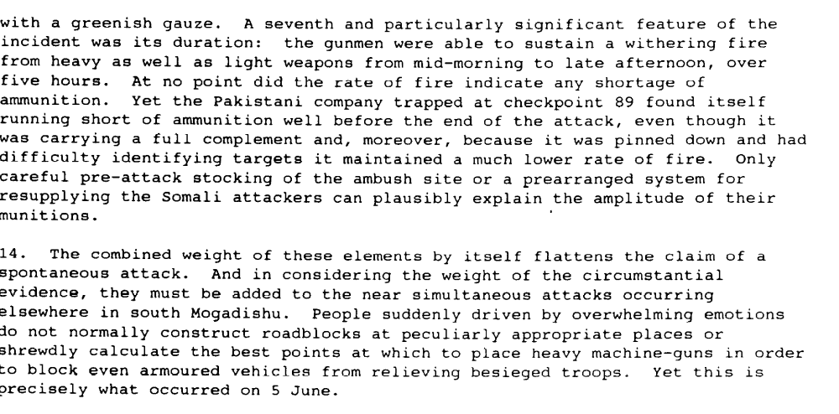

Report of the Secretary-General on the Situation in Somalia, 24 August 1993, S/26351

Assessment

Short-term compliance
X No or marginal compliance (1) | Medium low compliance (2) | Medium high compliance (3) | Full or almost full compliance (4)

Considerations underlying the assessment

Within the six months following the adoption of the resolution, the demand addressees did not take all measures to ensure the safety of the personnel of the United Nations and its agencies as well as the staff of the International Committee of the Red Cross (ICRC), intergovernmental organizations and non-governmental organizations engaged in providing humanitarian and other assistance to the people of Somalia in rehabilitating their political institutions and economy and promoting political settlement and national reconciliation

Medium-term compliance

Description of the addressee(s)’ conduct

“Violations of humanitarian law in internal conflicts by Somalis have been common since the civil war began in 1991. The use by factions of women and children as human shields or combatants in conflicts is well-documented. The brutalities of armed looters who continue to roam Somalia are unlikely ever to be completely catalogued. Humanitarian convoys and base camps were the targets of these bandits. The Geddo region on the border with Kenya, unprotected by UNOSOM deployment, suffered
severely. When the remnants of Somalia's judiciary formed an association, they particularly wanted inquiries into war crimes to focus on the looting of relief supplies. Except in regions with UNOSOM protection, humanitarian aid workers were constantly under threat, often in pay disputes with their armed Somali employees. Three non-Somali humanitarian aid workers were murdered in incidents of random violence”

U.S. DEPARTMENT OF STATE. “SOMALIA HUMAN RIGHTS PRACTICES, 1993 JANUARY 31, 1994 U.S. DEPARTMENT OF STATE.
http://dosfan.lib.uic.edu/ERC/democracy/1993_hrp_report/93hrp_report_africa/Somalia.html

“The warring factions continued to commit numerous violations of humanitarian law throughout the year, including the killing of many civilians, particularly in Mogadishu and Kismayo. In February heavy interfactional fighting between the forces of Colonel Omar Jess and General Mohammed Hersi Morgan in Kismayo killed at least 60 civilians. In April fighting between General Aideed's SNA militia and the Hawadle, a rival Hawiye subclan, in Merca and southern Mogadishu, killed another 32 civilians. At year's end, with the approaching departure of UNOSOM, heavy factional fighting in Mogadishu over access to the port area reportedly killed 20 persons and wounded hundreds more.
(...)
Armed Somali factions continued to target UNOSOM peacekeeping troops, beginning in January with the wounding of two Indian soldiers in an ambush near Kismayo. Subsequent attacks resulted in deaths of peacekeepers from India, Egypt, Nepal,
Malaysia, Pakistan, and Zimbabwe. Armed bandits and militia often targeted peacekeepers in order to seize supplies or to retaliate against actions by UNOSOM forces.
(...)
International humanitarian nongovernmental organizations (NGO's) and others, including journalists (see Section 1.a.), increasingly became targets for attacks by Somali factions and bandits. These attacks were widespread and often without clear
motivation, although in some cases warlords sought to extort money from aNGO's in exchange for providing security. After 50 armed Somalis looted 340 tons of food from a World Food for Peace (WFP) warehouse in January, more than 15 relief organizations decided to reduce or cease operations for a time in various parts of the country because of the lack of security. The few NGO's that remained in operation at year's end had experienced continuous harassment and disruption of their operations at the hands of the warring factions.

U.S. DEPARTMENT OF STATE. “SOMALIA HUMAN RIGHTS PRACTICES, 1994
JANUARY 31, 1995 U.S. DEPARTMENT OF STATE.
http://dosfan.lib.uic.edu/ERC/democracy/1994_hrp_report/94hrp_report_africa/Somalia.html

Assessment

Medium-term compliance
X No or marginal compliance (1) | Medium low compliance (2) | Medium high compliance (3) | Full or almost full compliance (4)

Considerations underlying the assessment

Within the two years following the adoption of the resolution, the demand addressee did not take all measures to ensure the safety of the personnel of the United Nations and its agencies as well as the staff of the International Committee of the Red Cross (ICRC), intergovernmental organizations and non-governmental organizations engaged in providing humanitarian and other assistance to the people of Somalia in rehabilitating their political institutions and economy and promoting political settlement and national reconciliation.

Depth of demand

Assessment

Level of depth of demand
Low depth of demand (1) | X Medium depth of demand (2) | High depth of demand (3)

Considerations underlying the assessment
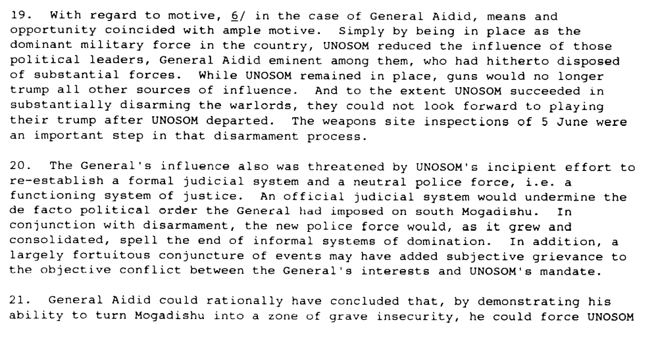
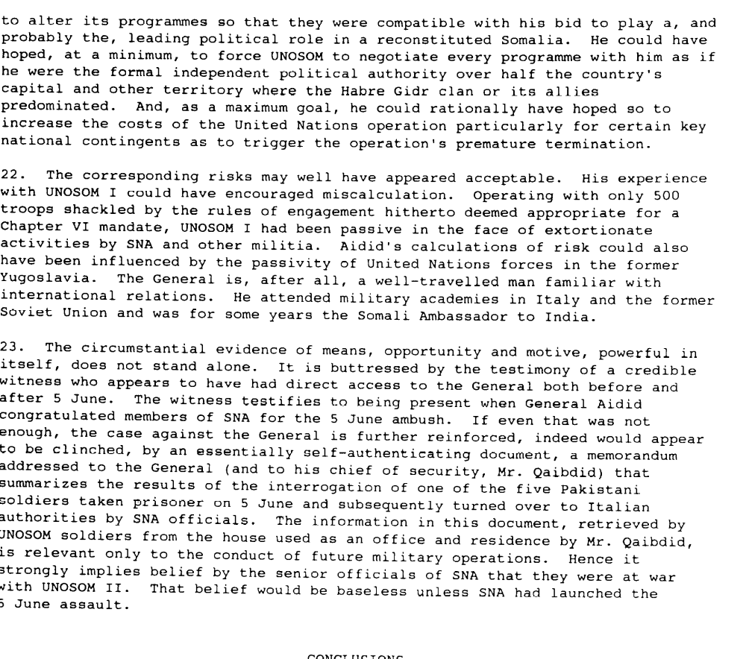

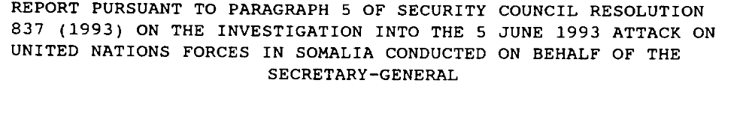

Level of confidence about coding decisions

Level of confidence about coding decision
Extremely high | X High | Moderate

Comments to IPI (if any)

